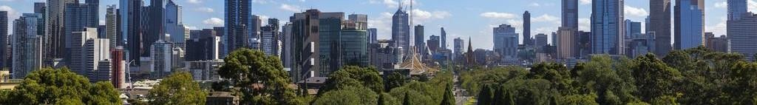

**PROGRAM**

**Study Tour Australia 2020**

**Module 1:**

|  |  |  |  |  |  |  |  |  |  |  |
| --- | --- | --- | --- | --- | --- | --- | --- | --- | --- | --- |
| **Day** | **Sat Day 1** | **Sun Day 2** | **Mo n Day 3** | **Tue Day 4** | **Wed Day 5** | **Thu Day 6** | **Fri Day 7** | **Sat Day 8** | **Sun Day 9** | **Mon Day 10** |
| **Mor** | Depart from your country | Melbourn e Arrival Pick up and transfer to Host Families | Welcome Ceremony, College visit and presentati on | Study English with local teachers | Excursion: Visit **Melbourne Museum** – *Team building: History of Victoria* | Study English with local teachers | Study English with local teachers | **Visit Animal Park and Phillip Island:**  *Make familiar with Australian Specific Animals like Koala, Kangaroo, penguins*  *Admire* ***Penguins Parades****.* | Relax and Culture Exchange with Host Family, Shopping and Departure | Arrive in your country End Study Tour |
|  |
| **Aft** | Study & join activities with local students | Study & join activities with local students | Excursion: **Visit Victorian Space & Science Centre**  – Experience the most advanced sciences on Space. | Study & join activities with local students | Study & join activities with local students |
| **Eve** | Dinner, Relax and Culture Exchan ge with Host  Family | Dinner, Relax and Culture Exchange with Host Family | Dinner, relax and Culture exchange with Host Family | Dinner, Relax and Culture Exchange with Host Family | Dinner, Relax and Culture Exchange with Host Family |

Program A: Melbourne – 10 Days

**STUDY TOUR PROGRAM AUSTRALIA 2020**

**TOTAL PRICE OF STUDY TOUR PROGRAMS AUSTRALIA 2020**

|  |  |  |  |
| --- | --- | --- | --- |
| ***PRICE per student, unit: AUD*** | | | |
|  | 10 – 19 students  Shared room | 20 + students  Shared room | Each Adult accompanied |
| **PROGRAM A: MELBOURNE 10 DAYS (1 week study and Australian experience)** | | | |
| **Homestay** | 1.968 | 1.766 | 980 |

# PRICE INTERPRETATION OF PROGRAMS

The above prices of Study Tour Australia 2020 include:

|  |  |
| --- | --- |
| **Service** | **Detail** |
| **Homestay/Apartment Cost** | Shared room 2 students per room, 2 meals per day (breakfast & dinner) from Monday to Friday |
| **Tuition & Lunch fee at school** | Include tuition fee and lunch fee at school each day (including a 1 day picnic cost per week) |
| **Melbourne, Sysdney, Canberra Tour** | Include admission fee, 3 meals per day, and tour guide |
| **Domestic air ticket Melbourne**  **– Sydney** | Domestic flight (7kg carry-on baggage + 25kg check-in baggage) |
| **Transport cost daily** | By standard travel coach |
| **Airport transfer cost** | By standard travel coach |
| **Farewell party cost & gifts** |  |

Excluding:

1. International Air Ticket Indonesia – Australia,
2. Australian Visa application cost
3. Travel Insurance Cost
4. Personal costs

**2. TIME, PAYMENT & OTHER CONDITIONS**

# TIME

Estimated time: 06/06/2020 Registration time: Until 10/03/2020

# PAYMENT

Confirm booking (number of students, schedule length, date, etc) of program must be before the arrival date (at least 60 days).

Upon confirmation of booking, 15% deposit of the program price (non-refundable) before the arrival date at least 60 days.

The remaining 85% of the program's cost must be paid at least 30 days prior to the arrival date.

# OTHER CONDITIONS

Students attending summer camp are those in grade 7 to 11.

Groups of students will be able to be divided into two different schools. Minimum booking unit is 10 days.

A group of 10 students is required to have 1 adult accompanied. For every 10 students registering, there will be free for 1 adult.